LP Problem – Performance Analytics

Submitted by - Souvik Samanta

Roll No – 19PGDM064

13/10/2020

# Problem 1

Question –

*A small business sells two products, named Product 1 and Product 2. Each tonne of Product 1 consumes 30 working hours, and each tonne of Product 2 consumes 20 working hours. The business has a maximum of 2,700 working hours for the period considered. As for machine hours, each tonne of Products 1 and 2 consumes 5 and 10 machine hours, respectively. There are 850 machine hours available. Each tonne of Product 1 yields 20 Me of profit, while Product 2 yields 60 Me for each tonne sold. For technical reasons, the firm must produce a minimum of 95 tonnes in total between both products. We need to know how many tonnes of Product 1 and 2 must be produced to maximize total profit.*

library(lpSolve)  
# Setting objective function  
f.obj <- c(20, 60)  
  
# Defining constraints  
f.con <- matrix(c(30, 20,  
 5, 10,  
 1, 1), nrow = 3, byrow = TRUE)  
  
# Set unequality signs  
f.dir <- c("<=",  
 "<=",  
 ">=")  
  
# Set right hand side coefficients  
f.rhs <- c(2700,  
 850,  
 95)  
  
# Final value of objective function  
lp("max", f.obj, f.con, f.dir, f.rhs)

## Success: the objective function is 4900

# Final value of optimal parameters  
lp("max", f.obj, f.con, f.dir, f.rhs)$solution

## [1] 20 75

# Problem 2

Question –

*Let’s consider a transportation problem of two origins a and b, and three destinations 1, 2 and 3. In Table are presented the cost cij of transporting one unit from the origin i to destination j, and the maximal capacity of the origins and the required demand in the destinations. We need to know how we must cover the demand of the destinations at a minimal cost.*

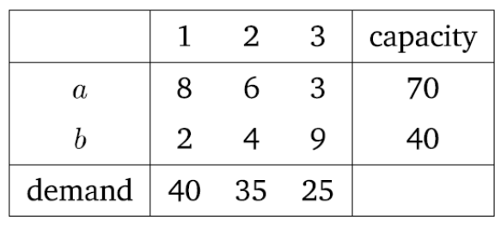

# Setting objective function  
f.obj <- c(8, 6, 3,2,4,9)  
  
# Defining constraints  
f.con <- matrix(c(1, 1,1,0,0,0,  
 0,0,0,1,1,1,  
 1,0,0, 1,0,0,  
 0,1,0,0,1,0,  
 0,0,1,0,0,1), nrow = 5, byrow = TRUE)  
  
# Set unequality signs  
f.dir <- c("<=",  
 "<=",  
 ">=",  
 ">=",  
 ">=")  
  
# Set right hand side coefficients  
f.rhs <- c(70,  
 40,  
 40,  
 35,  
 25)  
  
  
# Final value of objective function  
lp("min", f.obj, f.con, f.dir, f.rhs)

## Success: the objective function is 365

# Final value of optimal parameters  
lp("min", f.obj, f.con, f.dir, f.rhs)$solution

## [1] 0 35 25 40 0 0